**Amman Bars**

The tiles that are forced by a given patch of tiles can be determined by decorating the tiles as shown below, and then insisting that tiles be placed so the extra markings form straight lines.  These lines, known then as "Amman Bars", are then extended across the plane, and any other tile must have its markings on an Amman Bar.

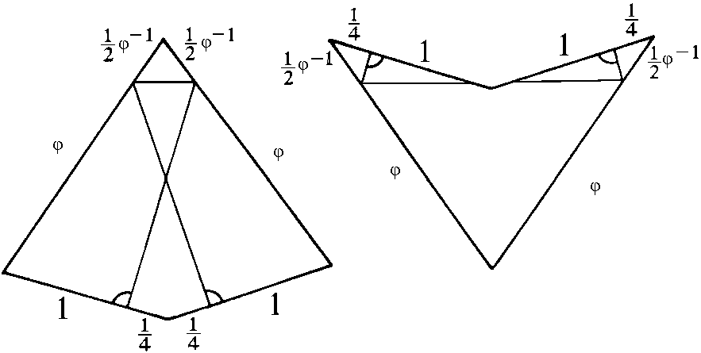

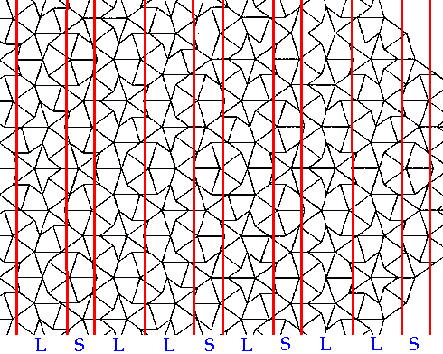At left we have a tiling with Amman bars in one direction.  Note that adjacent bars are always a longer (L) of a shorter (S) distance apart.  The ratio of these distances is the golden ratio.  Note also that there are 6 L's and 4 S's.  If you take a big enough piece of the tiling, this ratio tends as well to the golden ratio.  The sequence that a tiling generates will never have SS or LLL.  These sequences can be deflated much like a Penrose tiling:  replace every S by L, LL by S, drop all single L's.  To inflate, replace L by S, S by LL, and add L between a pair of S's.  If you deflate or inflate a Penrose tiling, the Amman sequences are also deflated or inflated.    
If two families of parallel bars are placed at the proper angle to each other, a Penrose tiling is determined.  This raises the question:  Is the tiling or the configuration of Amman bars the essential item?

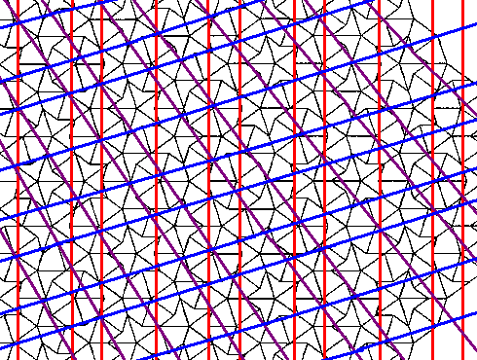In the image at left, Amman bars have been drawn in 3 directions.  If you wanted to, you could draw them in two more directions.  
The Amman sequences exhibit the same sort of local isomorphism properties at the tilings do:  If you find a string, say LSLLS, you never have to go very far in the sequence to find an identical string.  This is  a great contrast to many other nonperiodic phenomena.  For instance, the digits of an irrational number don't have this property.

[The ratio of kites to darts is phi](https://ksuweb.kennesaw.edu/~sedwar77/tile/aperiodic/penrose2/phiratio.htm)  [Aperiodic Tiling](https://ksuweb.kennesaw.edu/~sedwar77/tile/aperiodic/index.htm)